Global Center invites you to
"Field Trip to Ganghwado"
Greetings!
IFEZ Global Center is inviting expats interested in the Korean history to "IFEZ Field Trip to Ganghwado" -you’ll visit and experience tourist sites in Ganghaw Island.

"IFEZ Field Trip to Ganghwado“
< 1st session : Lecture >
∘ Subject : Local history of Ganghwado
∘ Date & Time : May 12, 2022 (Thr) 14:00 ~ 16:00
∘ Place : Global Center, IFEZ
*Only participants in the 1st session can come to the field trip of 2nd session.

< 2nd session : Field Trip to Ganghwado>
∘ Date & time: May 19, 2022 (Thr) 9:00 ~ 17:00
∘ Meeting point: May 19, 2022 (Thr) 08:50 / Main entrance at IFEZ Global Center
<< Itinerary >>
Gwangseongbo Fort → Jeondeungsa Temple→ Anglican Church of Korea, Gangwha Cathedral → Yongheunggung Royal Residence → Ganghwa History Museum → Dolmen in Bugeun-ri → Ganghwa Peace Observatory → Yeonmijeong Pavilion
*It is subject to availability
∘ Participants: Expats living in IFEZ with an account of social media (Facebook, Instagram, etc.)
∘ Requirement: Have an account of social media (Facebook, Instagram, etc.) and post a review with photos within 7 days after the field trip.
∘ Transportation: by bus and on foot
∘ Contents: Take a lecture and visit tourist sites in Ganghwado
∘ Fee: Free of charge
∘ Registration: https://forms.gle/g4y9385jyLdLVFkM9 (Limited to 12 persons, only adults)
∘ Registration period: May 4th, 2022 (Wed) 10:00~
∘ Contact: 032)453-7663 / email: ifezglobal@gmail.com / website : http://global.ifez.go.kr
∘ IFEZ Global Center: 1F G-tower 175 Art center dae-ro, Yeonsu-gu, Incheon

∘ Detailed schedule
 | Duration | Activity
Departure | 09:00 ~ 10:00 (60m) | ㅇ Departure from IFEZ Global Center  ㅇ Arrival at Gwangseongbo Fort
Schedule | 10:00 ~ 10:50 (50m) | ㅇ Gwangseongbo Fort tour
Schedule | 10:50 ~ 12:10 (80m) | ㅇ Jeondeungsa Temple
Schedule | 12:10 ~ 13:10 (60m) | ㅇ Lunch
Schedule | 13:10 ~ 13:40 (30m) | ㅇ Anglican Church of Korea, Gangwha Cathedral
Schedule | 13:40 ~ 14:10 (30m) | ㅇ Yongheunggung Royal Residence
Schedule | 14:10 ~ 15:00 (50m) | ㅇ Ganghwa History Museum & Dolmen in Bugeun-ri
Schedule | 15:00 ~ 15:30 (30m) | ㅇ Ganghwa Peace Observatory
Schedule | 15:30 ~ 16:00 (30m) | ㅇ Yeonmijeong Pavilion
Arrival | 16:00 ~ 17:00  (1hr) | ㅇ Departure from Yeonmijeong Pavilion  ㅇ Arrival at IFEZ Global Center
☞ The Schedule above is subject to change.

▣ Tour Course Information
Gangwha Island is a large island located to the east of Incheon International Airport and is a part of Incheon city, which is located just east of Seoul. Gangwha has a rich historic past as it is the 'gateway' into Korea. Towards the end of the 19th century, Korea opened its borders after a lengthy time of being a closed and protected 'Hermit Nation'.
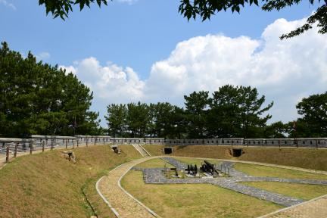 | Gwangseongbo Fort was an important fortress along with Deokjinjin, Chojijin, Yonghaejin Forts and Munsusanseong Fortress in the defense the Ganghwa Strait. The Goryeo Dynasty erected the outer fortress of Ganghwa (1233~ 1270) while it moved its capital to Ganghwa Island for do-or-die resistance against the invasion of the Mongols.
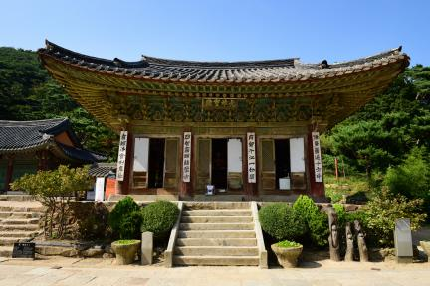 | Jeondeungsa Temple is said that the entire temple was burnt to the ground by two large fires in 1605 (the 38th year of the reign of King Seonjo of the Joseon Dynasty) and in 1614 (the 6th year of the reign of King Gwanghaegun of the Joseon Dynasty), that reconstruction work was begun the following year, and that the temple regained its original appearance in 1621 (the 13th year of the reign of King Gwanghaegun).
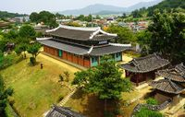 | Anglican Church of Korea, Gangwha Cathedral Korean architecture and Anglican tradition are blended together in this beautifully designed Hanok style church. Established in 1900 by Bishop Charles John Corfe(Korean name: Go Yohan(고요한)), Gangwha Cathedral is an example of how beautiful it can be when two cultures harmonize.
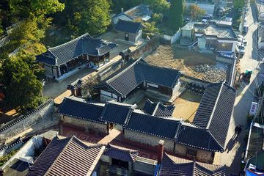 | Yongheunggung was the residence where King Cheoljong (r. 1849-1863), the 25th king of the Joseon dynasty, once lived. He lived here because his family had been exiled to Ganghwa due to his brother's involvement in treason in 1844. When the preceding king, Heonjong (r. 1834-1849), died without an heir, Cheoljong, a member of the royal Yi family, was selected to become king.
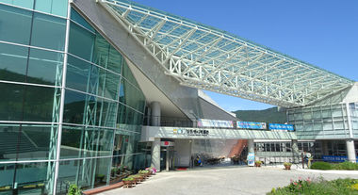 | Ganghwa History Museum has opened on October 23, 2010. It was established to systematically display, preserve and study the history and culture of Ganghwa Island from prehistoric times to modern times.
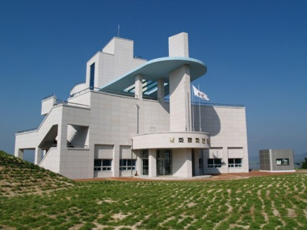 | Ganghwa Peace Observatory, was constructed on the forest land in the northern area of the Civilian Passage Restriction Line at Cheolsan-ri Yangsa-myeon. It can be recalled that the entry to this area was once strictly prohibited for the general public since the end of 2006. Since its public opening on September 5, 2008, it has been providing accessibility to visitors for them to get an in-depth look on the unique cultural ecosystem of North Korea that may not be experienced in other areas.
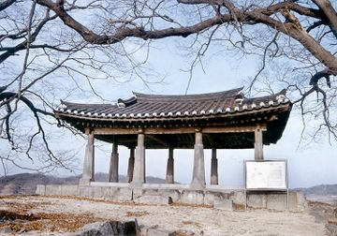 | Yeonmijeong Pavilion overlooks the mouth of the Imjingang and Hangang Rivers. Its name means “Pavilion of a Swallow’s Tail,” as the shape of the waterway around this pavilion resembles a swallow’s tail.  It is unknown when Yeonmijeong was first built, but it is presumed to have been sometime during the Goryeo period (918-1392). In 1244, King Gojong (r. 1213-1259) gathered young scholars from the capital city, Gaegyeong (present-day Gaeseong, North Korea), to this pavilion for summer study. The pavilion was destroyed during the Korean War and was reconstructed in 1976.

