Korean Traditional Dance

Sogo-choom
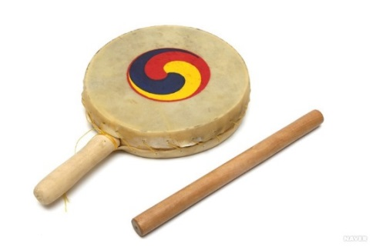
‘Sogo’ is a small traditional percussion with a handle, and ‘chum’ means dance. Sogo-chum is one of major Korean dance performances. The dance originated from farming moves, hunting, and wars. ‘Sogo’ is a sub-tool rather than providing rhythm. Please find the ironical dance movements of how battles and physical labors have turned out into a sophisticated dance move.

Nanta
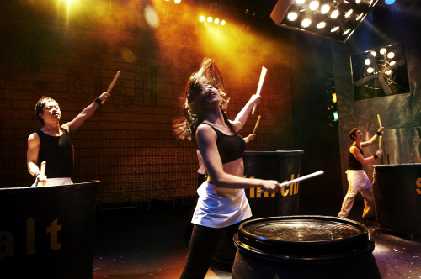
Word itself has a meaning of ‘heating without order’. Nanta is a unique style of musical performance interpreted in Korean way. It is a non-verbal performance and provides the mixture of Korean rhythm and jazz. The strong beat is made by normal tools and appliances and is performed in a place where we face in daily lives. Enjoy the powerful Korean rhythm provided by common objects. If you are wondering about Korean rhythm, help yourself to attend Nanta and find yourself in it.

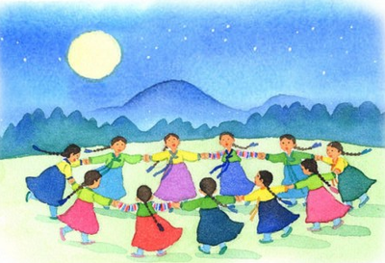
Ganggangsullae
Traditionally, Koreans believe that the universe is controlled by the Sun, Moon, and Earth. Women gather together and make a big round circle which is motivated from the full moon. By drawing circles under the full moon, dancers pray for good harvest. During the Japanese invasion in 16th century, women were ordered to dance in a military uniform on the mountain under the moon and Japanese watch men thought there were more troops. Ganggangsullae was designated as ‘Important Intangible Cultural Properties’ by UNESCO in 1966 on February 15th. In the past, women were not allowed to dance or sing except this one day. Enjoy not only the dance but also innate meanings of Ganggangsullae.

Booche-choom
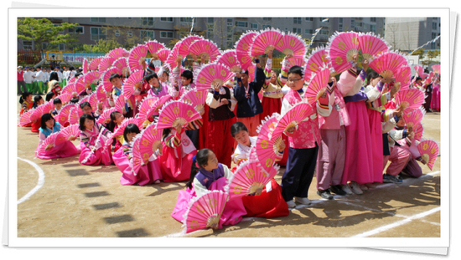
Be ready to fall in love with Korean Fan Dance called ‘Booche-choom’. It is widely used in many traditional ceremonies. Performers dance with large and glamorous fans wearing colorful Hanbok, the Korean traditional wear. The large fans are painted with blossoms and with ‘booche’, dancers represent birds, flowers, butterflies, and waves. It is originated from shaman’s dance which is used for spiritual events.

