M6405

detail information
(allocation time:10~15Min)
(The first bus from Songdo 05:00) /(The last bus from songdo 23:30)
(The first bus from Gangnam Sta 05:50)/The last bus from Gangnam Sta 23:30)
(bus operation: 인강여객)
(key number:032-885-6900)

A bus line
Well County Apt → Central Park → GS Xi Apt → Pungrim 2,3 cha Apt → Hanjin Apt → Yonsei Univ Songdo Campus → Seonbawi Station → Seocho Xi Apt → Seocho Station → Gyo-dae Station(Line No.2) → Gangnam Station(turn place) → Weoksam-dong, Woosung Apt → Yangjae Station, Seocho-gu Community Center →
Yangjae Citizen’s Forest → Seonbawi Station → Seongji Apt → Munwoogm Elementary School → GS Xi Apt → Central Park → Well County Apt → University of Incheon, Colleage of Engineering

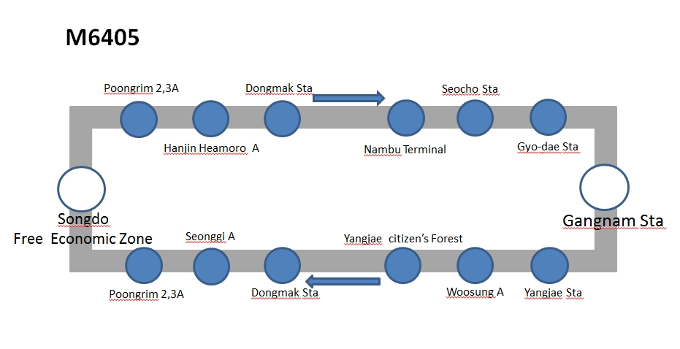

M6724

detail information
(allocation time:15-20Min)
(The first bus from stating point 05:00) /(The last bus last stop 23:10)
(The first bus from stating point 05:50)/The last bus from last stop 23:30)
(bus operation: 청룡교통)
(key number:032-584-0890)

The-sharp First World → Songdo Xi Harbor view → The shop expo village → Poongrim I-won Apt(2) → Yonsei Univ → Dongchun Sta → Gangseo District Tax Office → Hapjeong Sta → Hongik Univ. Sta → Yonsei Univ Main Entrance → Sinchon Sta(line N0 2) → Sinchon a five-way Crossing /Hyundai Department Store
Hongik Univ. Sta → Hapjeong Sta → Gangseo District Tax Office → Dongchun Sta(line NO.5) → Yonsei Univ → Poongrim I-won Apt(1) → The shop expo village
Prugio Harborview → Convensia

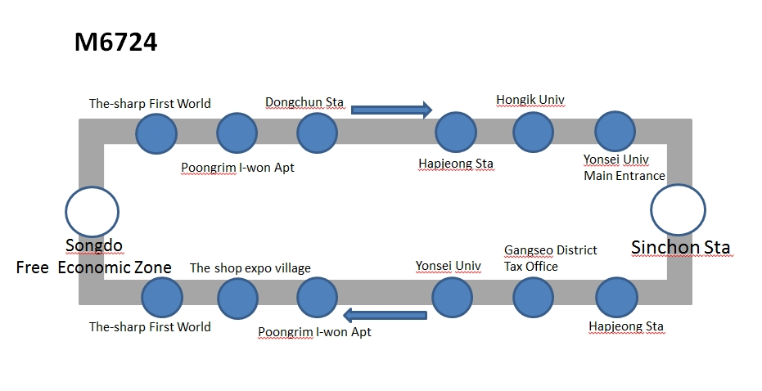

908

detail information
(allocation time:18-20Min)
(The first bus from stating point 05:00) /(The last bus last stop 23:00)
(The first bus from stating point 05:30)/The last bus from last stop 00:00)
(bus operation: 천지교통)
(key number:032-424-7878)

Songdo Public Management Garage → Incheon Univ Natural Science → Incheon Univ Main Entrance → Incheon Univ Etrance Sta → Central Park Sta → Free Economic Zone → Central Park1 → GS Xi Apt → Songdo HillstateA → Songdo Poongrim I-won → Hanjin Apt → Dongmak Sta(gate 1) → Dongchun Sta → Woninjae Sta(gate 1) → Sinyeonsu Sta(gate 1) → Seonhak Sta(gate 1) → Farm Center → Shinsegae Department Store → Namincheon Girl’s Middle School → Hansin Apt → Juan 7dong Resident Center → Incheon Firefighting Safety Head Office → Jungseok Aviation Science High Shool → Inha Univ Back gate → Inha Univ Back gate → Jungseok Aviation Science High School → Incheon Firefighting Safety Head Office → Juan 7dong Resident Center → Hansin Apt → Namincheon Girl’s Middle School → Shinsegae Department Store → Complex Terminal → Munhak Sports Complex → Seonhak Sta → Sinyeonsu Sta(gate 3) → Woninjae Sta(gate 4) → Dongchun Sta → Dongmak Sta(gate 3) → Seonggi Apt → Songdo Poongrim I-won Complex1 → Korea Coast Guard → GS Xi Apt → Prugio Harborview → Free Economic Zone → Central Park Sta → Incheon Univ Etrance Sta → Incheon Univ Main Entrance → Incheon Univ Natural Science → Songdo Public Management Garage



