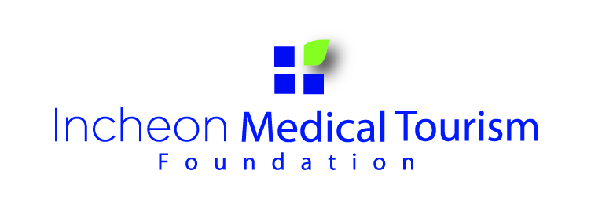
Incheon Medical Tourism
Idea Contest
Incheon Medical Tourism Foundation is holding
an Incheon Medical Tourism Idea Contest
and we hope many of you will apply for this contest.

◻ Overview

★ Contest topic
1. What are the advantages of Incheon Medical Tour
2. How to promote Incheon Medical Tourism to your country
3. Open topic related Medical Tourism

★ Participation Qualification
: Foreign residents living in Incheon

★- Participation Date
: May 19th, 2014 – June 30th, 2014
★ Awards (5 Persons)
: Voucher for Free Medical Examination (KRW 800,000 worth)
* The validity of the voucher will be for six months.

★ Announcement Date : July. 4(Fri.), 2014
★ Award Ceremony : July. 9(Wed.), 2014
** Date of the Award Ceremony is subject to change without prior notice.
◻ How to apply
★ Submission Documents
1. Idea Essay
▻ MS Word (doc)
▻ letter font;12pt, line-spacing;160%, A4 2~3pages
▻ Pictures may be submitted but must be attached separately
▻ Must be submitted only in English
2. One Copy of I.D (shown current address)
- Submission Venue
: Fill in the application form attached
: Email it with your Idea Essay to
dkcla128@gmail.com titled “Incheon Medical Tourism Idea”
: or Visit Global Center with documents

◻ Awards
★Announcement Date : July. 4(Fri.), 2014
: Individual Notification
: Notify on http://global.ifez.go.kr/jsp/global/front.jsp (Global Center)
http://medical.incheon.go.kr/open_content/en/aboutus/notice.jsp
(Incheon Medical Tourism Foundation)
★ Procedure
1. Presents vouchers to 5 winners.
2. Visit Global Center → complete health questionnaire →
Make appointment for medical examination
3. Result can be checked in the hospital
or will be sent by email one week later after examination.

※ Notice
- All entry essays must be original piece of work and applicant will be responsible for all civil and criminal legal disputes arising from the contest.
- Plagiarism or essays submitted to other contests will be excluded from evaluation and in case detected after it has been awarded, the award will be retracted and prize redeemed.
- Submitted Documents will not be returned and Incheon Medical Tourism Foundation shall have all rights to the submitted idea essays.

※ For more information
Contact us by phone (032-458-5794) or e-mail (dkcla128@gmail.com)
or Visit Medical Information Center at
Global Center, G-Tower 1st floor
175 Art Center-daero, Yeonsu-gu, Incheon

Application
* Please Print Both application forms. (for applicant)
Name |  | Number | (Do Not Write)
Nationality |  | Tel (Mobile) #
Gender | Male ________ Female _______ | Registration #
Occupation |  | Period of stay  in Korea
Address
E-mail
---------------------------------------------------------------------------------------------------------------------------------------------------------
Application
* Pedriod of Application: May 19th, 2014 – June 30th, 2014
* Announcement Date: July 4(Fri), 2014 (for IMTF)
**All your answers will remain confidential, and will be exclusively used for statistical purpose.
Name |  | Number | (Do Not Write)
Nationality |  | Tel (Mobile) #
Gender | Male ________ Female _______ | Registration #
Occupation |  | Period of stay  in Korea
Address
E-mail
Family

Incheon Medical Tourism Idea Contest

1. What are the advantages of Incheon Medical Tour
2. How to promote Incheon Medical Tourism to your country
3. Open topic related Medical Tourism
(Please state your idea about what are the advantages of Incheon Medical Tour or how to promote Incheon Medical Tourism to your country or open topic related Medical Tourism )
(Please print; letter font;12pt, line-spacing;160%, A4 2~3pages)

