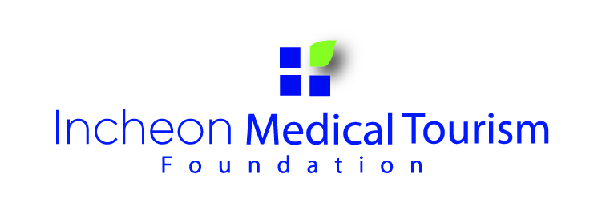
Application
* Please Print Both application forms. (for applicant)
Name |  | Number | (Do Not Write)
Nationality |  | Tel (Mobile) #
Gender | Male ________ Female _______ | Registration #
Occupation |  | Period of stay  in Korea
Address
E-mail
---------------------------------------------------------------------------------------------------------------------------------------------------------
Application
* Pedriod of Application: May 19th, 2014 – June 30th, 2014
* Announcement Date: July 4(Fri), 2014 (for IMTF)
**All your answers will remain confidential, and will be exclusively used for statistical purpose.
Name |  | Number | (Do Not Write)
Nationality |  | Tel (Mobile) #
Gender | Male ________ Female _______ | Registration #
Occupation |  | Period of stay  in Korea
Address
E-mail
Family

Incheon Medical Tourism Idea Contest

1. What are the advantages of Incheon Medical Tour
2. How to promote Incheon Medical Tourism to your country
3. Open topic related Medical Tourism
(Please state your idea about what are the advantages of Incheon Medical Tour or how to promote Incheon Medical Tourism to your country or open topic related Medical Tourism )
(Please print; letter font;12pt, line-spacing;160%, A4 2~3pages)

