▣ District 1
1. Bornga 본가 (beer) 831-8288
2. The Big Apple 빅 애플 (Pasta) 831-5331
3. What's David's? 왓츠 데이비스 (Pasta) 833-1225
4. Pier39 피어 39 (Beer) 832-3910
5. BM Factory 비엠팩토리 (Burgur) 070-4156-7421
6. Gul Hyanggi 굴향기 (Oyster) 834-6668
7. Young heui's Kitchen 영희네 부엌 (Pork) 212-9988
8. Ta-bang 타방 (Beer) 833-1225
9. Hoo Woo 호우양꼬치 (Lamb) 858-3999
10. Hair Story Today 헤어스토리 오늘 (Hair shop) 833-2447
11. Songdo Ironwork 송도종합철물 (Ironwork) 858-5094
12. Flower & Tree 꽃이랑 나무랑 (Flower) 832-0771
13. Cozy Nails 코지네일 (Nail shop) 833-8566
14. Livestock Story 축산이야기 (Pork) 858-7747
15. K 516 (Cloth) 831-0343
16. PIZZERIA 피자리아 (Pizza) 834-7222
17. Music&Sound 뮤직&사운드 (Guitar) 832-3360
18. Café Chosun 카페 조선 (Pork) 858-9282
19. Teawongak 태원각 (Chinese restaurant) 851-0083
20.PAPA JOHN’S PIZZA 파파존스피자 (Pizza) 032 833 8081
21.MIGA 미가참치일식 (Japanese food) 032 833 3711

▣ District 2
1. Paris Baguette 파리바게트 (Bakery) 851-8288
2. Caihong 차이홍 (Chinese restaurant) 858-3311
3. Songdo SingSing Seafood soup&stew 송도싱싱해물탕. 찜 858-9995
4. JangDokJib 장독집 (Traditional Korean Bar) 851-0900
5. Sangsiru 상시루 (Rice cake) 834-1007
6. Hanul 참치전문점 하늘 (raw tuna) 859-0037

▣ District 3
1. TVeer 티비어 (Beer) 859-7733
2. Donhoya 돈호야 (Songdo branch) 271-2222

▣ District 4
1. Sangomjangeo 산곰장어 (Eel) 832-3575
2. Seabyeokjib 새벽집 (Boild pork)859-1700
3. Vons Chicken 본스치킨 (Chicken) 858-5888

▣ District 5
1. 109 109돼지집 (Pork) 859-0109
2. Our town fish shop with stories 이야기가 있는 우리동네 생선가게 (fish) 831-1355

▣ District 6
1. Seoul Bulgogi 옛맛참숯서울불고기 (Bulgogi) 858-1101
2. Relish 래리쉬 (Salad bar) 858-7711
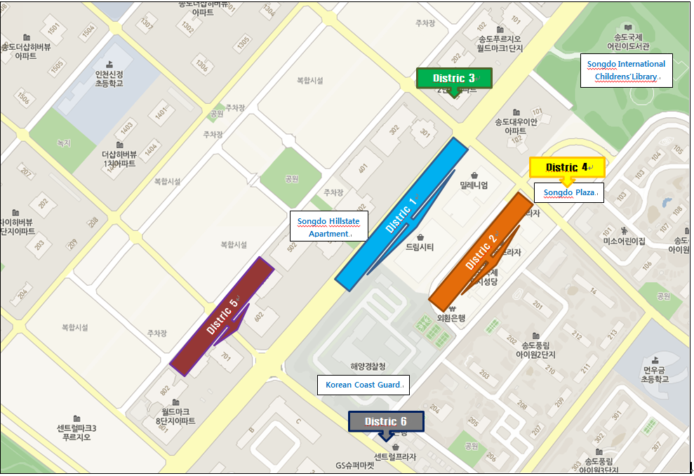

▣ District 7
1. J's recipe 제이스레시피 (Bakery) 834-5580
2. Cafe de Moim 카페드모임 (Cafe) 835-5997
3. Mango Six 망고식스 (Cafe) 834-7266
4. Saigon Kitchen 사이공 키친 (Vietnam noodle) 835-6786

▣ District 8
1. Comble 꽁블 (Teriyaki) 832-8334
2. Cozy Island 코지아일랜드 (Cafe) 835-5775
3. Kyungsun Pottery 경선도예공방 (Pottery) 835-6133
4. Samchuly Bike 삼천리 자전거 (Bike) 851-3020

▣ District 9
1. Kyedong 계동치킨 (Chicken) 858-9904
2. Mr. Coffee 미스터커피 (Cafe) 835-5636
3. OGADA 오가다 (Cafe) 835-5553
4. RAVISSSANT 라비쌍뜨 (Cafe) 835-7002
5. Quiznos Sub 쿠즈노스서브 (Sandwich) 835-5523
6. LK NewYork Lobster 엘케이 뉴욕랍스터 (Lobster) 811-5574
7. Mori 모리 (Beer) 835-5353
8. B1 (Beer) 858-7711
9.하꼬야 송도 포스코점 (HAKOYA) 835-6700

▣ District 10
1. Wootory 우토리 (café) 070-7733-1458
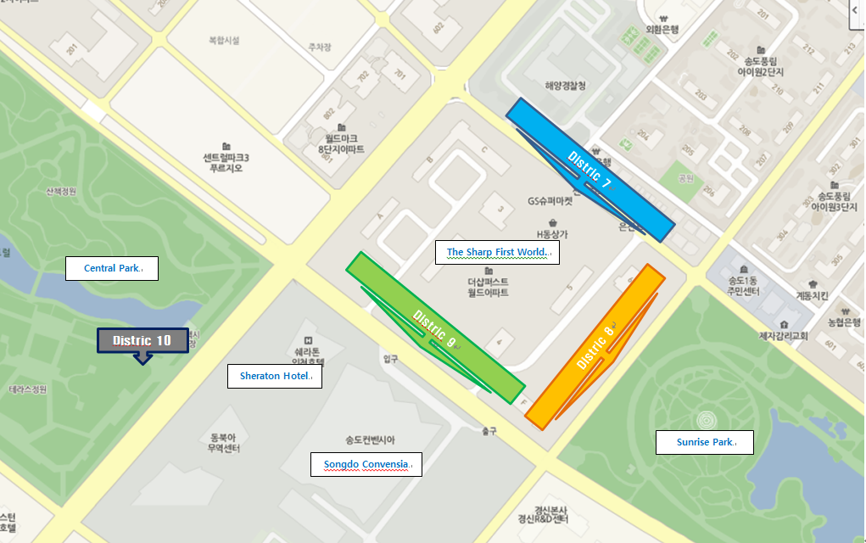

▣ District 11
1. Ewha Well Bom Pediatric Hospital 이화웰봄 소아과 833-7119
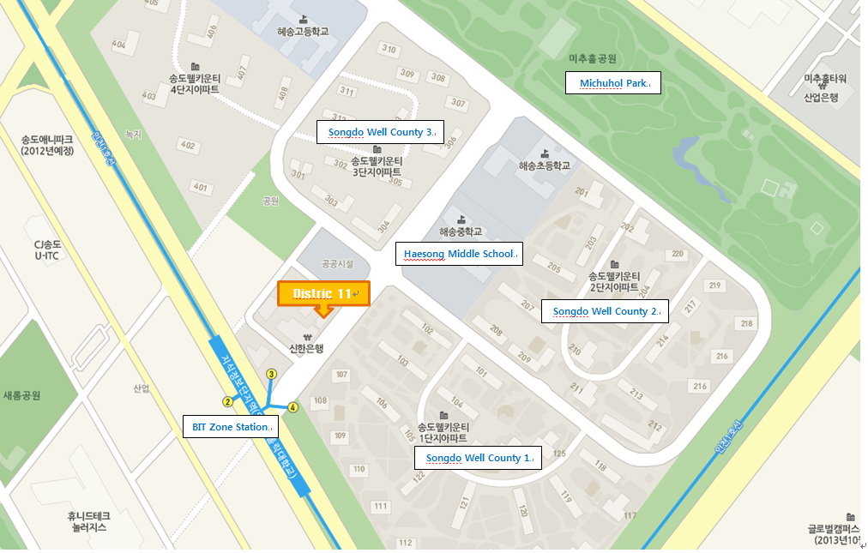
▣ District 12
1. Jason Coffee 제이슨 커피 859-0801
2. Lamaison 라메종 213-2474


