
IFEZ Global Center
G-tower 1st floor, Art center-daero 175, Songdo-dong, Yeonsu-gu, Incheon 406-840, Korea
Tel. 032-458-5790. Fax.032-458-5797. E-mail: sina4205@iirf.or.kr. http://global.ifez.go.kr

Korean Language Class at IFEZ Global Center
IFEZ Global Center will be offering free beginners and Intermediate and Advanced Level Korean Courses. Improve your Korean Language Skills through this opportunity.

· Course Duration: January 13, 2014 ~ April 18, 2014
· Location: Education Room, IFEZ Global Center (G-tower 1st Floor)
· Beginner Ⅰ Level: Mondays & Wednesdays (Twice a week), 16:00 ~ 17:30 (90min.)
· Beginner Ⅱ Level: Mondays & Wednesdays (twice a week), 17:40 ~ 19:10 (90min.)
· Intermediate Ⅰ Level: Tuesdays & Thursdays (twice a week), 17:00 ~ 18:00 (60min.)
· Intermediate Ⅱ Level: Tuesdays & Thursdays (twice a week), 18:10 ~ 19:10 (60min.)
· Advanced Level: Tuesdays & Thursdays (twice a week), 19:20 ~ 20:20 (60min.)
· Cost : Free of Charge (The textbook should be purchased by students)
· Admission : First come, First served basis.
· Class Size : Limited to 16 people
· Registration Procedure: Please fill in the application form attached and e-mail it to us (sina4205@iirf.or.kr) titled “Korean Language Class”

For further information please visit our website http://global.ifez.go.kr or
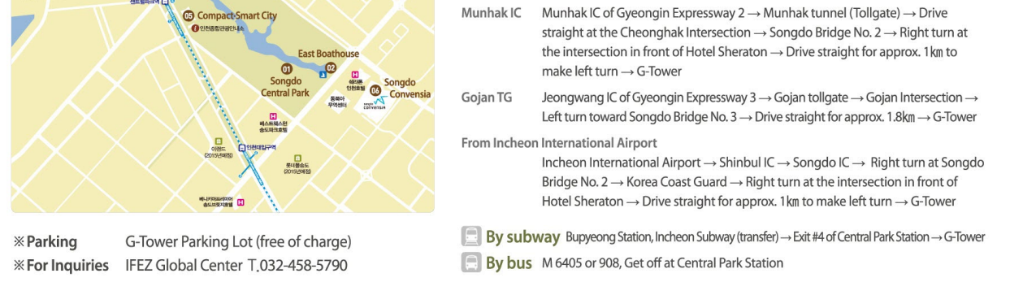
Contact us by phone (032-458-5790) or e-mail (sina4205@iirf.or.kr)
IFEZ Global Center
G-tower 1st floor, Art center-daero 175, Songdo-dong, Yeonsu-gu, Incheon 406-840, Korea
Tel. 032-458-5790. Fax.032-458-5797. E-mail: sina4205@iirf.or.kr. http://global.ifez.go.kr

Korean Language Application Form

*Preference:
BeginnerⅠ Beginner Ⅱ IntermediateⅠ IntermediateⅡ Advanced

*Personal Information
Name | (First) | (Last)
Nationality
Gender | Male | Female
Contact Info. | (HP)☎ | (email)
Current Job

Korean Language Experience
Have you ever studied Korean language before? | Yes | No
If you answer No, please skip to question f.
- Where did you study?
- When did you study?
- For how long did you study?
- Name of text book used
- Current proficiency
- What areas do you feel are your weakest or what do you want to improve in your Korean language abilities?

*How did you hear about the IFEZ Global Center Korean Language Class?
You must fill in every blank that has an asterisk.

